EXPERIMENT 3

Aim: To develop a flowchart in Figma depicting the operation of the Network Switching Subsystem (NSS) in a mobile cellular system.
Procedure:
- Open Figma and create a new design file.
- Add a title: Network Switching Subsystem (NSS).
- Use rectangles to represent the main components: Mobile Station, Base Station Subsystem (BSS), Mobile Switching Centre (MSC), Home Location Register (HLR), and Visitor Location Register (VLR). Use arrows to connect the components in the order of operation.
- Show the process of call initiation, subscriber verification, call routing, and call connection.
- Use different colours for each component to make the flowchart clear.
- Arrange all shapes neatly and add labels.
- Save the completed flowchart in Figma.
OUTPUT:
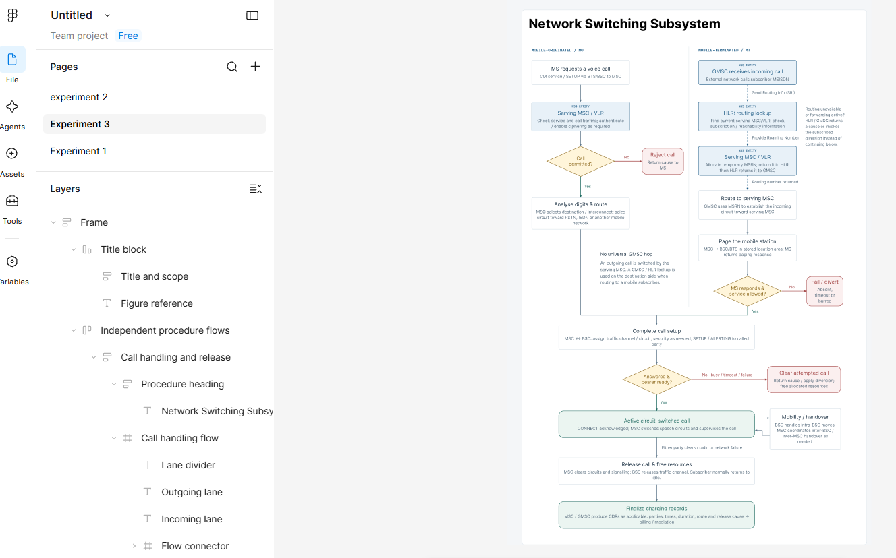
FIGMALINK: https://www.figma.com/design/ED1qcVpNfWi2Zuft4amJyZ/Untitled?node-id=8-2&p=f&t=agFau8l2OnHdtdLK-0
RESULT:
The flowchart illustrating the operation of the Network Switching Subsystem in a mobile cellular system was successfully designed using Figma. It explains subscriber verification, call routing, and call connection.

